EXPT NO:8 | FORECASTING AND PREDICTIVE ANALYTICS USING TABLEAU  AND POWER BI
DATE: 14.08.2026
Roll number:24BAD071

PRE-LAB QUESTIONS (PROVIDE BRIEF ANSWERS TO THE FOLLOWING QUESTIONS)

1.What is forecasting in the context of Business Intelligence (BI)?
Forecasting in BI is the process of predicting future business outcomes using historical and current data.
It helps organizations estimate future sales, demand, revenue, and other important metrics.
Forecasting supports better planning, decision-making, and resource management.

2. Explain the difference between predictive analytics and descriptive analytics.
Descriptive analytics focuses on understanding what has happened in the past using historical data.
Predictive analytics uses historical data, patterns, and statistical models to predict future outcomes.
For example, descriptive analytics reports past sales, while predictive analytics forecasts future sales.

3. Name two common forecasting methods used in Tableau and Power BI.
Two common forecasting methods are time-series forecasting and exponential smoothing.
Time-series forecasting uses historical patterns over time to predict future values.
Exponential smoothing gives greater importance to recent observations when making forecasts.

4. Why is data granularity important for accurate forecasting?
Data granularity refers to the level of detail in the data, such as daily, weekly, or monthly records.
The right level of granularity helps identify trends, patterns, and seasonal changes accurately.
Incorrect or overly detailed data can introduce noise and reduce the accuracy of forecasts.

5. Name two challenges in forecasting using multiple data sources.
Two common challenges are data inconsistency and data integration.
Different sources may use different formats, time periods, units, or definitions for the same data.
Combining and cleaning these sources correctly is necessary to produce reliable forecasting results.

IN-LAB EXERCISE:
OBJECTIVE:
To perform time series forecasting and predictive analytics on historical sales data using Tableau and Power BI, and visualize future trends for informed decision-making. PROCEDURE:
- Data Collection:
  - Import historical sales data from multiple sources:
    - Dataset 1: Sales Data (CSV) → Order ID, Order Date, Region, Sales Amount
    - Dataset 2: Promotions Data (Excel) → Promotion ID, Region, Promotion Start Date, Promotion End Date, Discount
- Data Preparation and Transformation:
  - Clean data: standardize date formats, remove duplicates, handle missing values.
  - Aggregate sales data at the required granularity (daily, weekly, or monthly).
  - Ensure numeric fields (Sales, Discount) are correct.
- Data Integration and Modeling:
  - Tableau: Connect datasets and relate them using the Region field.
  - Power BI: Create relationships in the Model view; define cardinality where necessary.
- Forecasting and Predictive Analytics:
  - Tableau:
    - Use the Forecast feature on Sales over time. o Apply trend models like Exponential Smoothing and visualize prediction intervals.
  - Power BI:
    - Use built-in forecasting in line charts. o Optionally, create a DAX measure for predicted sales using moving averages or linear regression.
- Create Calculated Fields:
  - Forecasted Sales = Predicted value from the model
  - Sales Growth % = ((Forecasted Sales – Actual Sales) / Actual Sales) * 100
- Design a Comprehensive Dashboard:
  - Line chart showing actual vs. forecasted sales over time.
  - KPI cards: Total Forecasted Sales, Expected Growth %.
  - Use combo charts to show sales trends along with promotion periods.
  - Highlight regions with expected growth above or below target thresholds.
- Validate Forecast Accuracy:
  - Compare forecasts against actual historical sales (back-testing).
  - Adjust forecasting parameters if necessary (e.g., seasonality length, smoothing factor).
- Publishing and Sharing:
  - Tableau: Publish workbook to Tableau Public or Tableau Server.
  - Power BI: Publish report to Power BI Service and share with stakeholders.
Experiment Datasets:
  - Dataset 1: Historical Sales Data (CSV) → Order ID, Order Date, Region, Sales
  - Dataset 2: Promotions Data (Excel) → Promotion ID, Region, Promotion Start/End Date, Discount

Power BI: https://app.powerbi.com/groups/me/reports/69d44274-5a7d-41b0-a1d7-c5f0ce23eeb5/ae364abce2b757fe4091?experience=power-bi

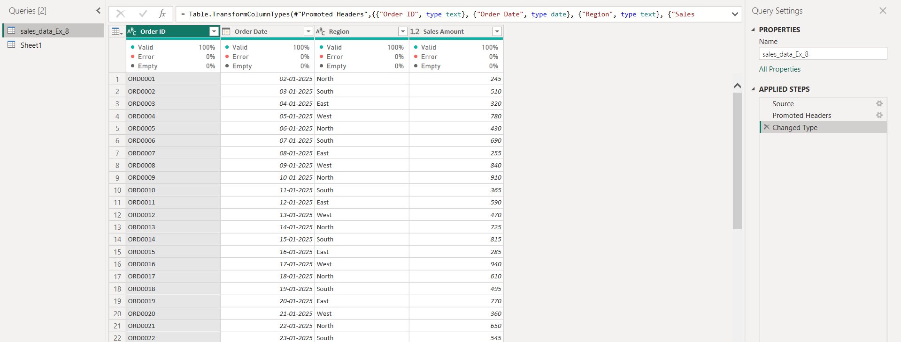

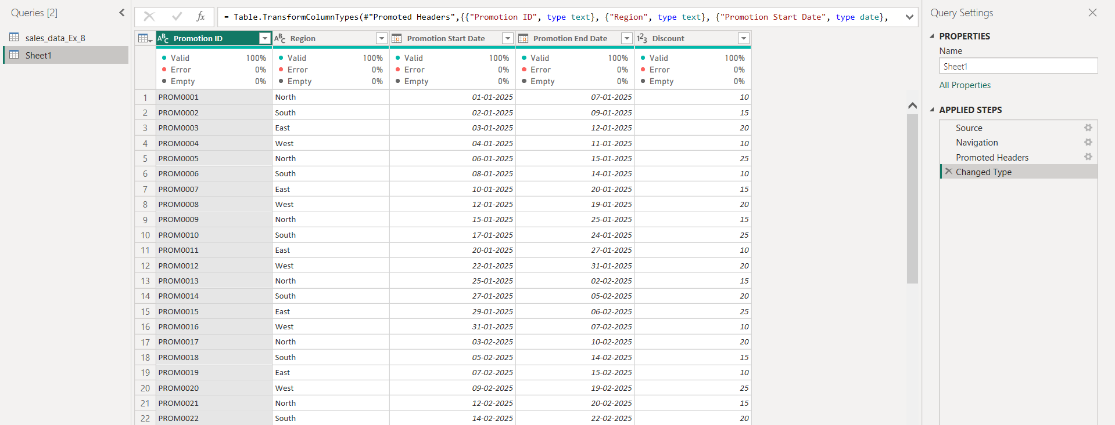

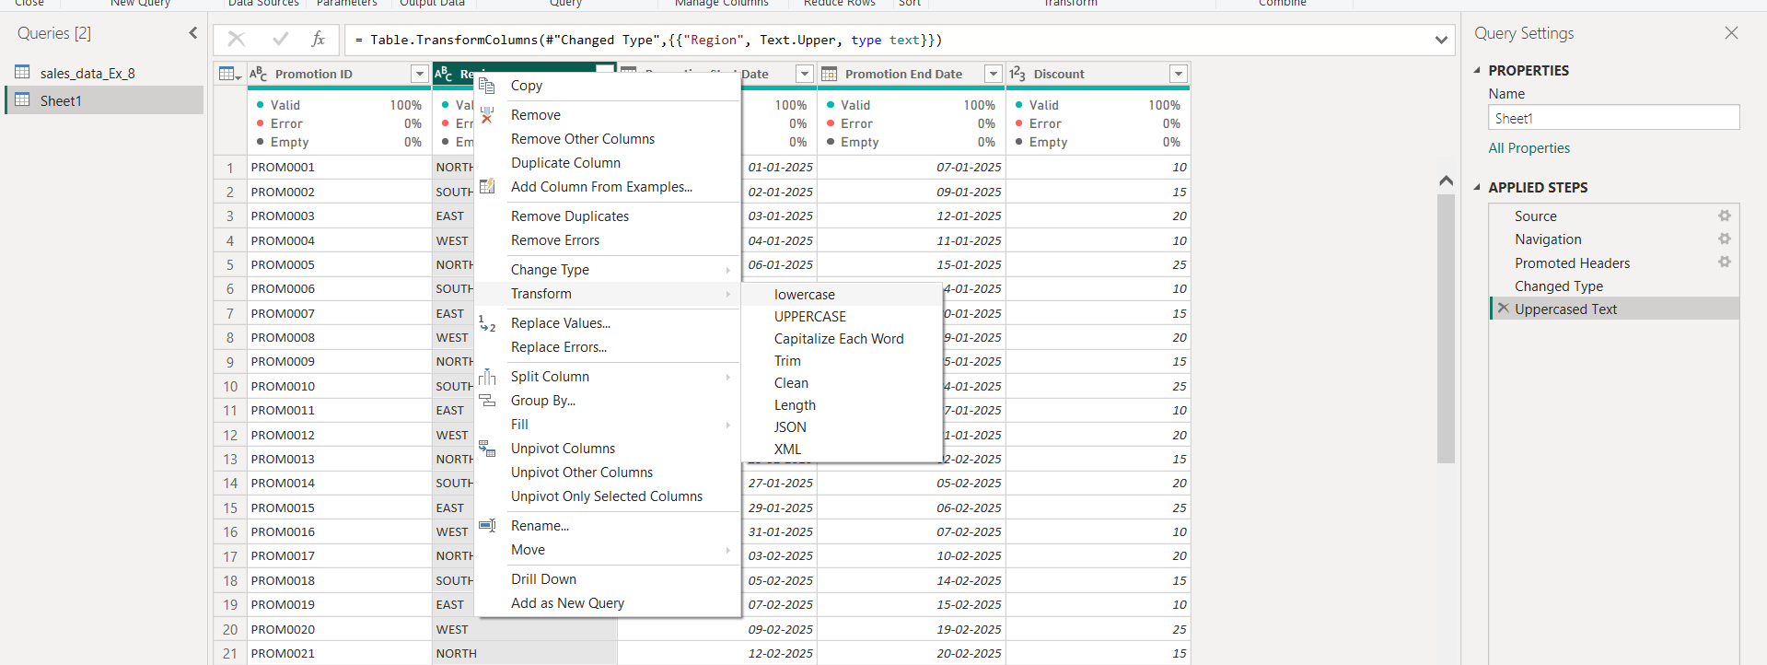

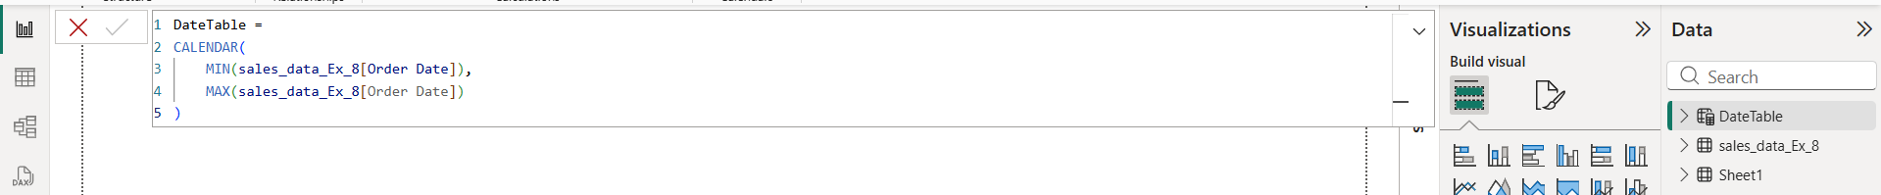

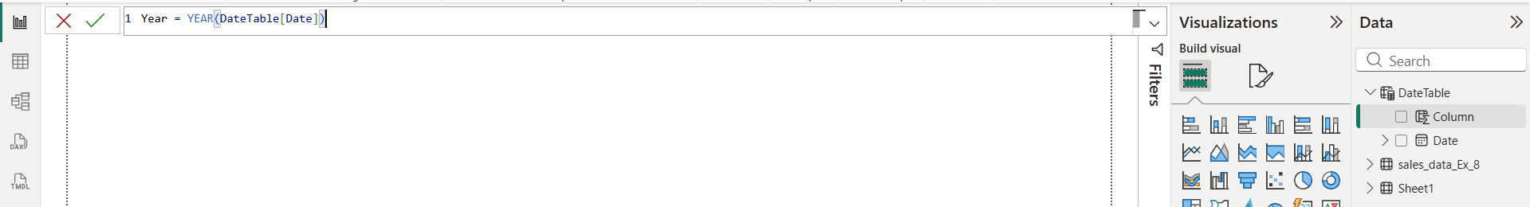

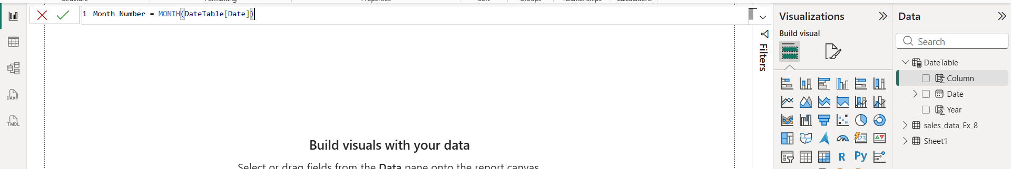

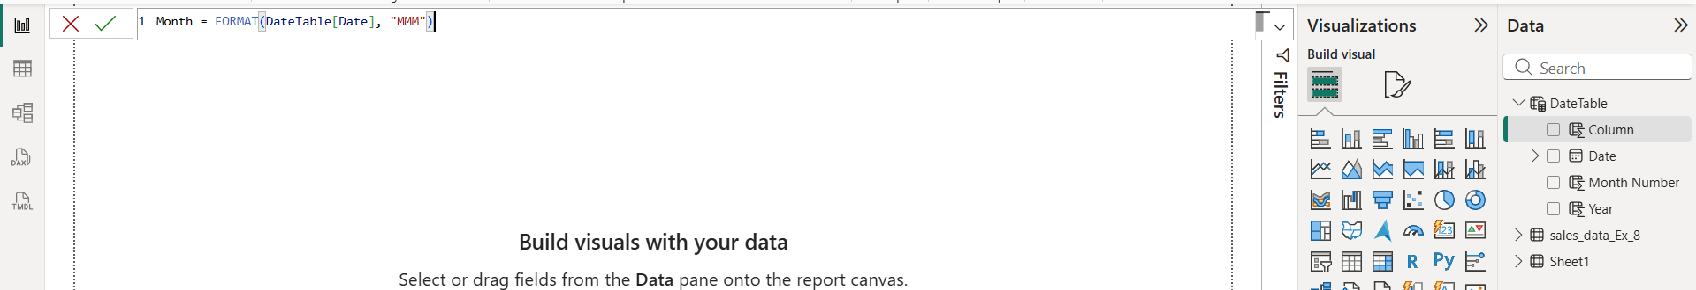

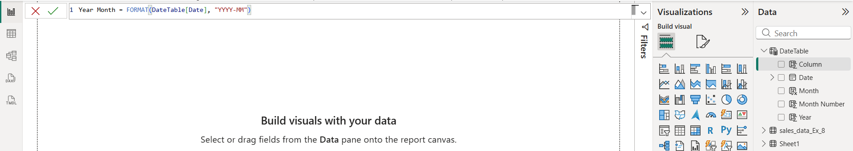
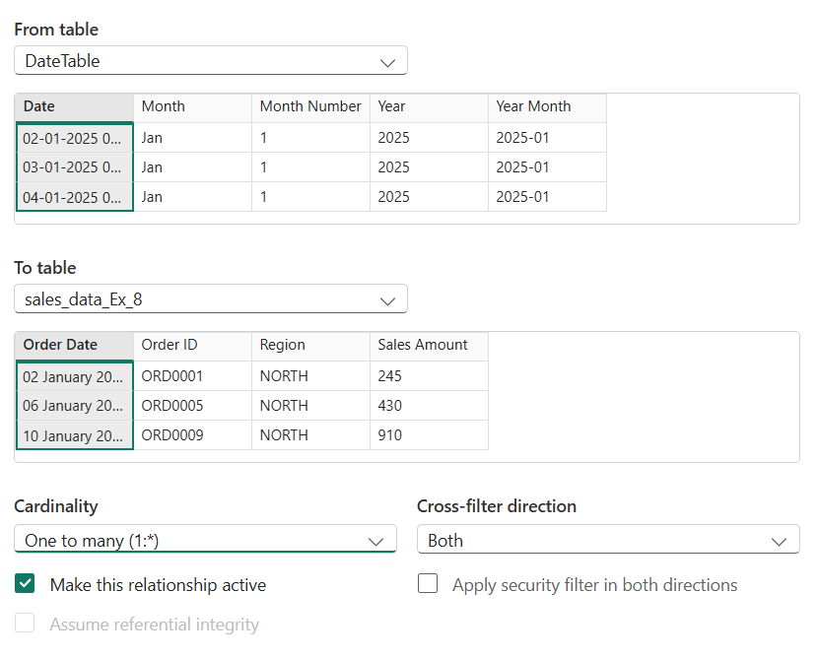
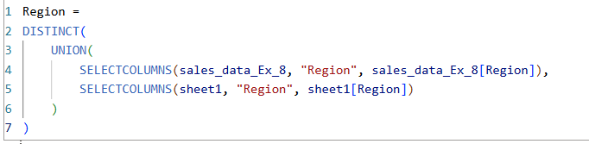
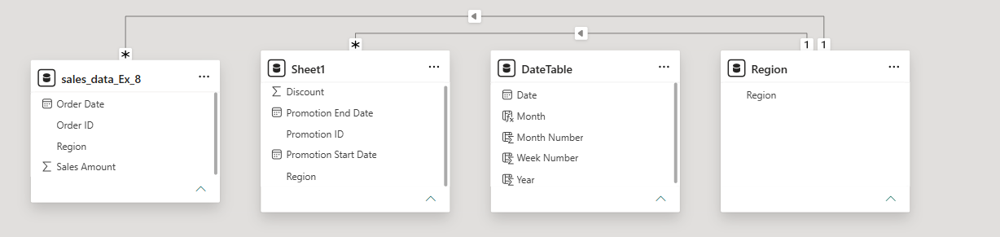
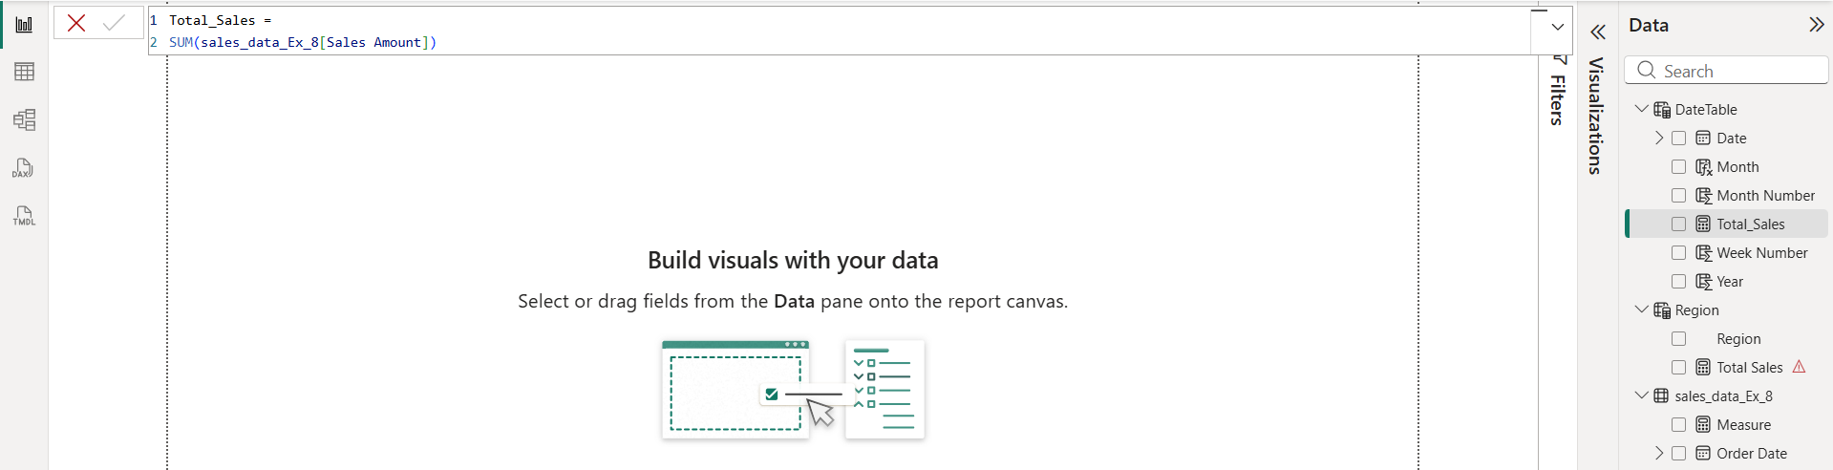

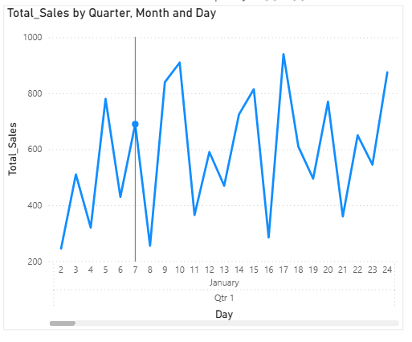
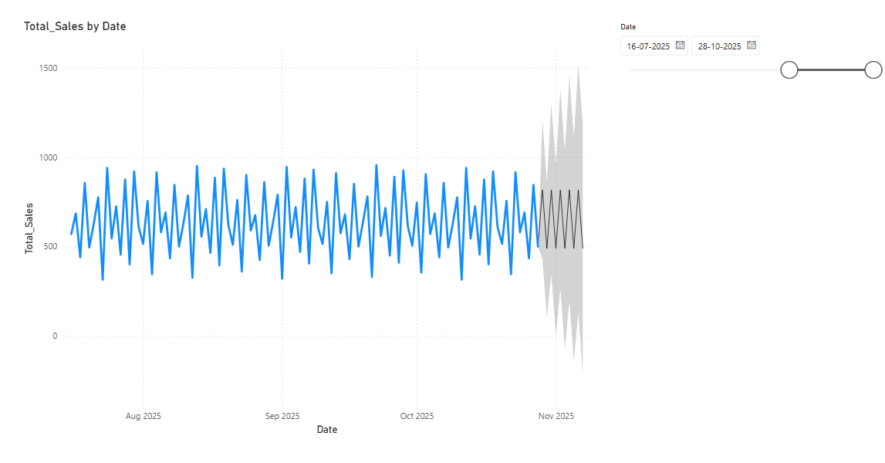

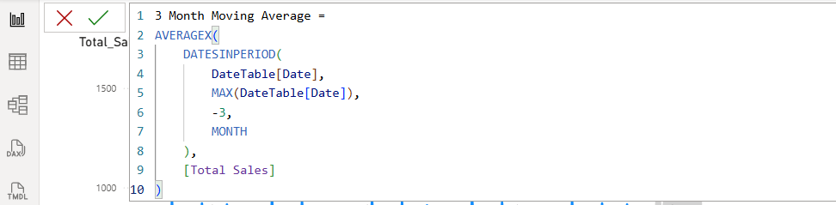

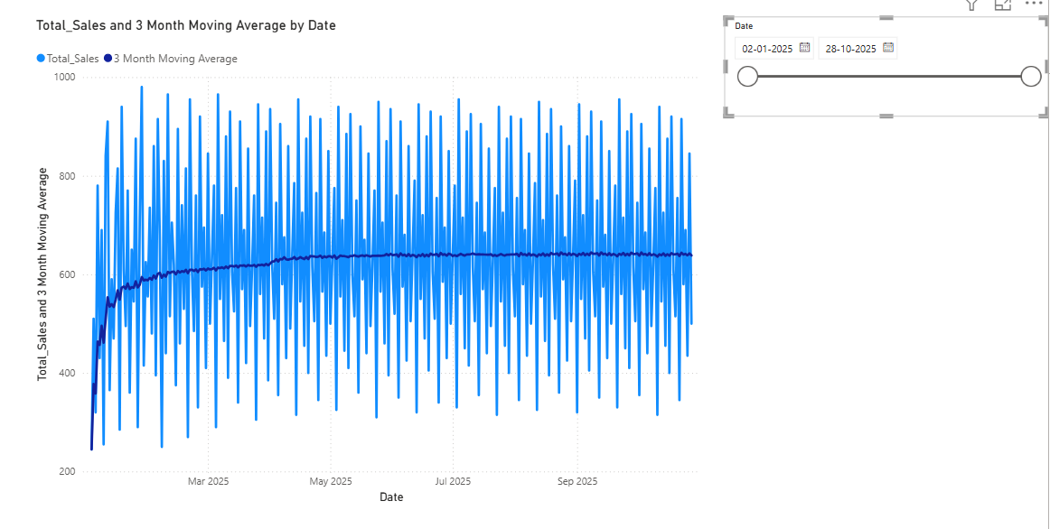
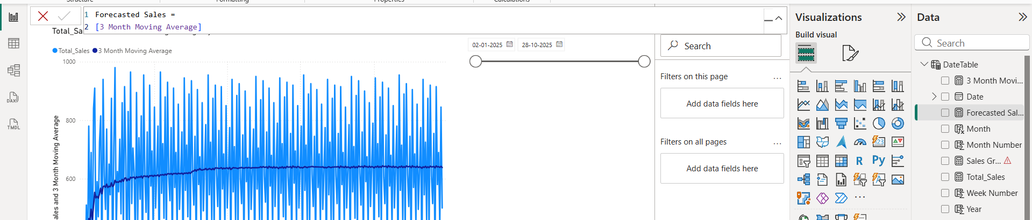
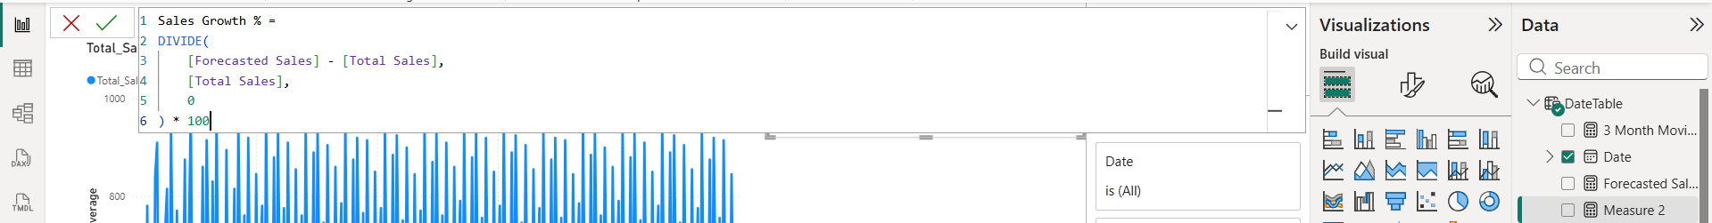
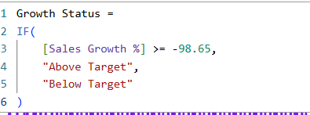
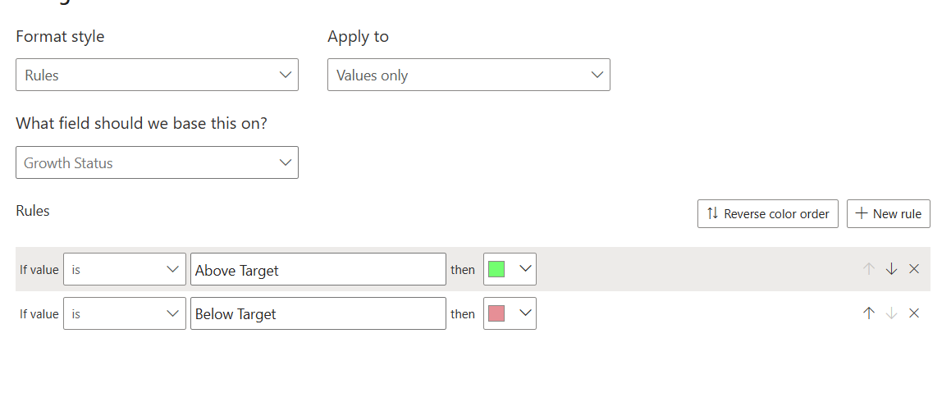
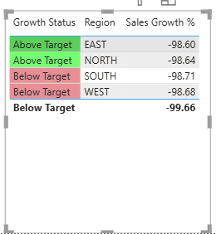

Final power BI dashboard
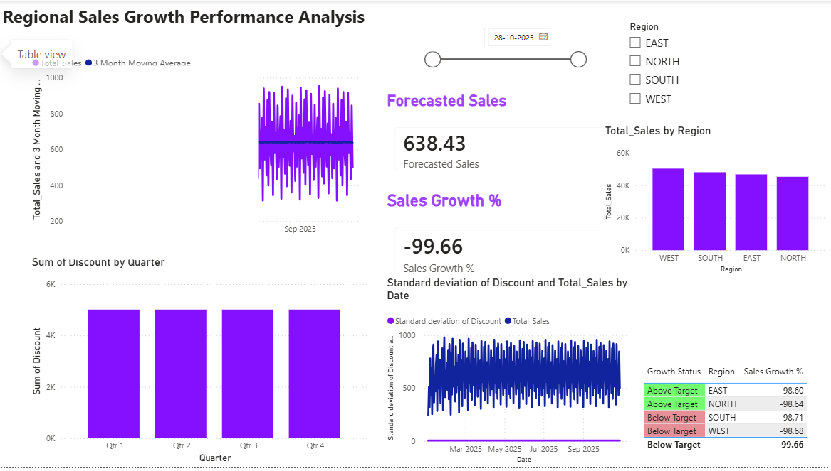

Tableau:
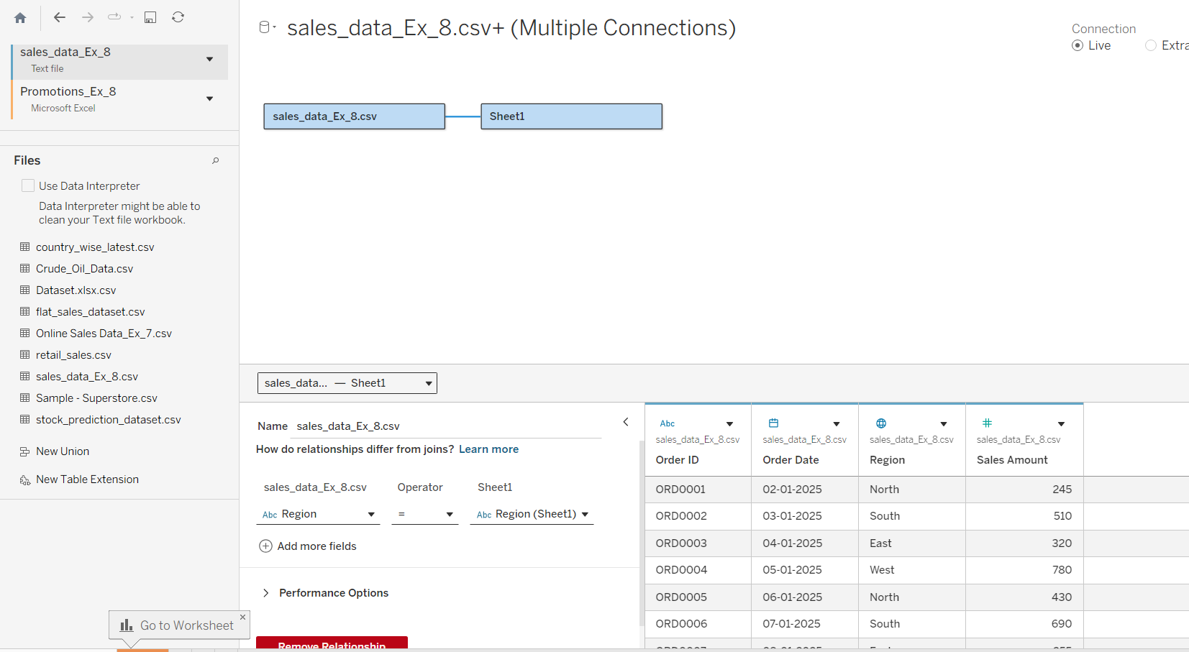

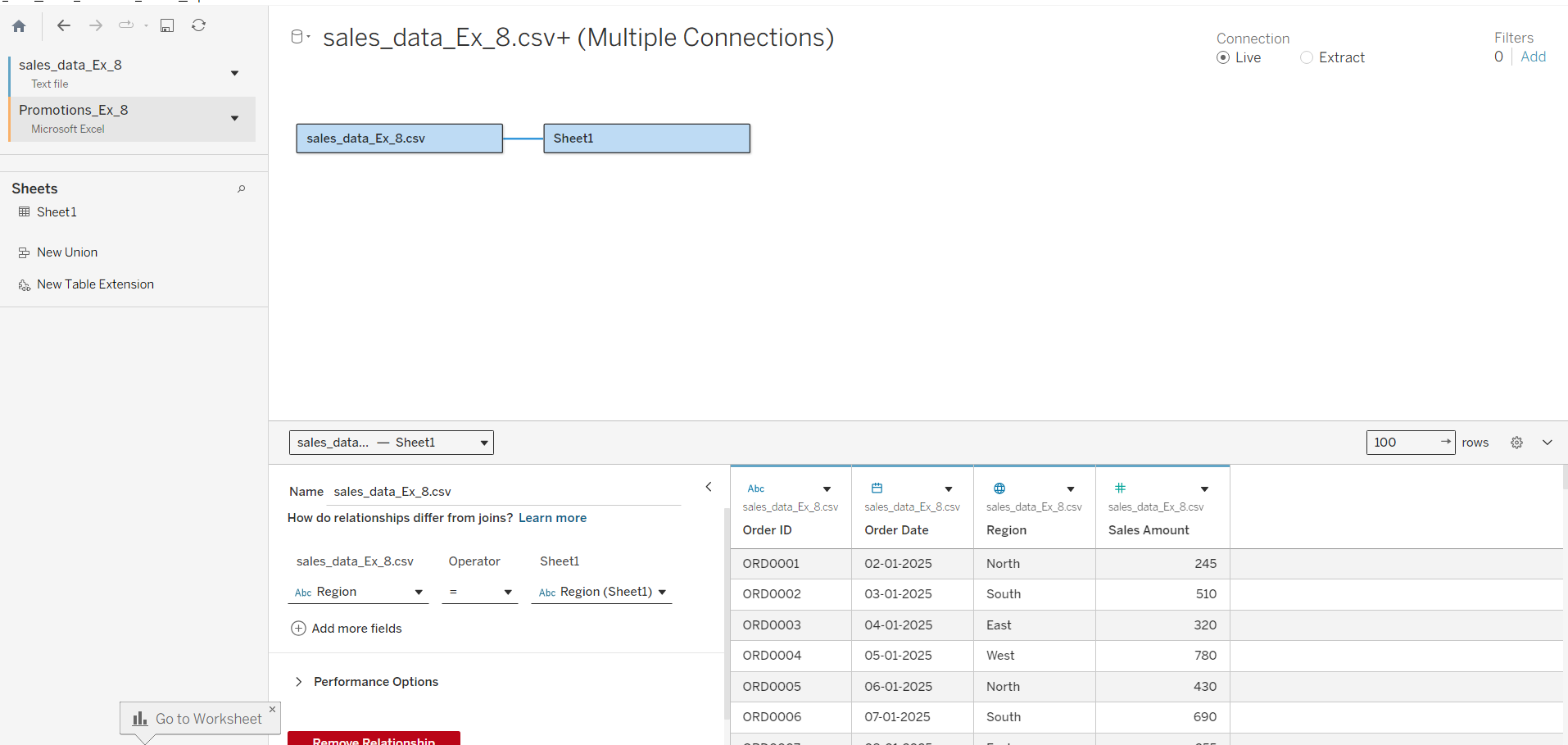

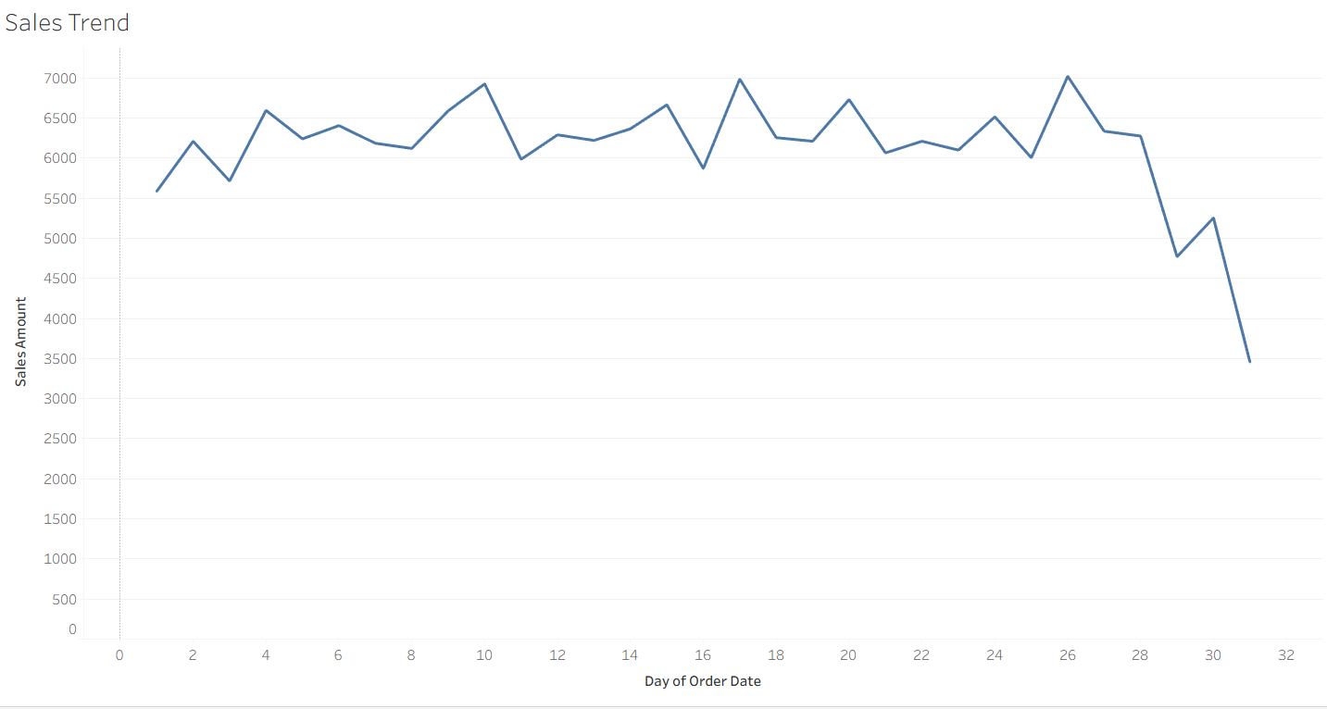

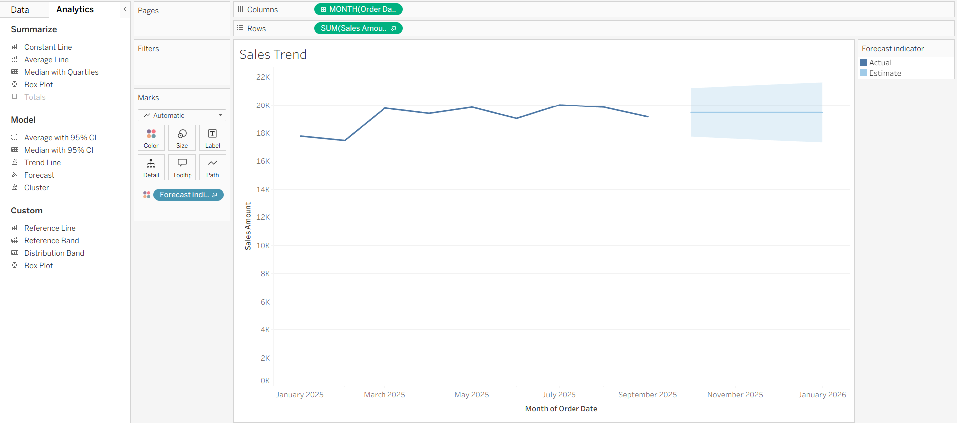

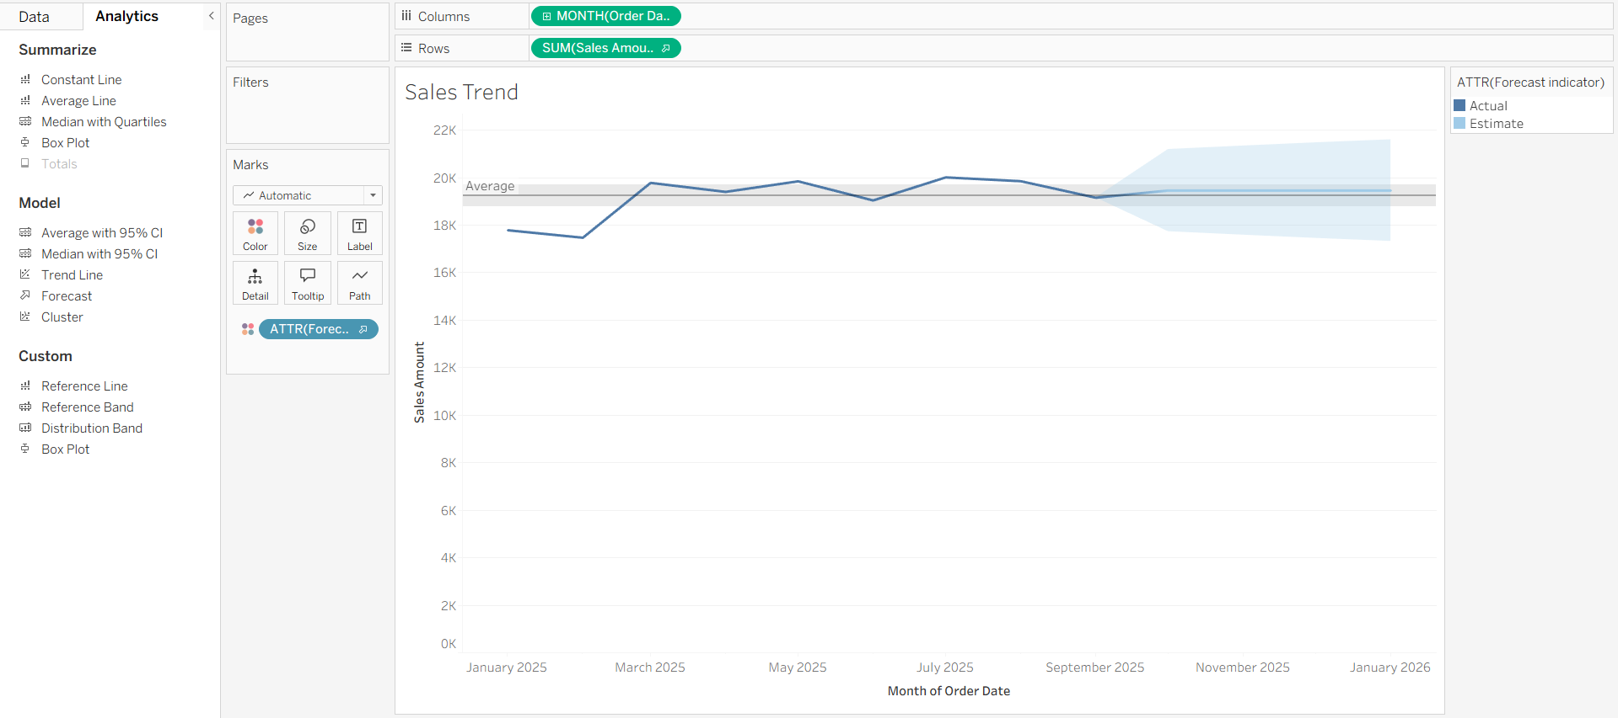

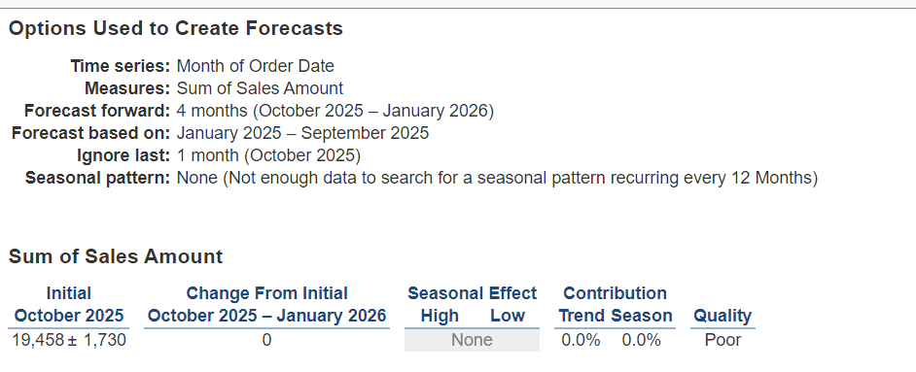

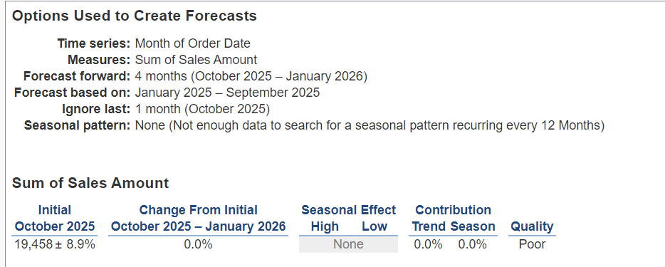

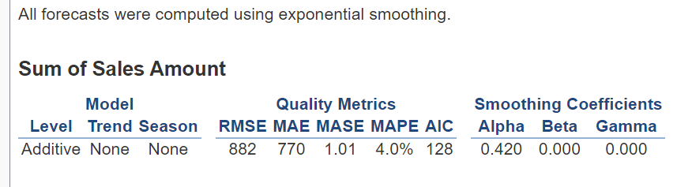

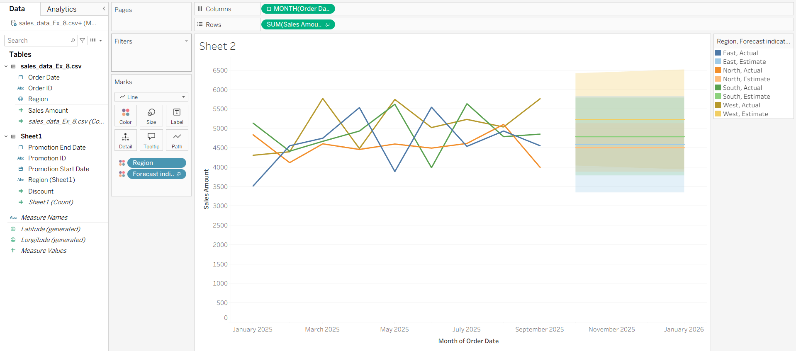
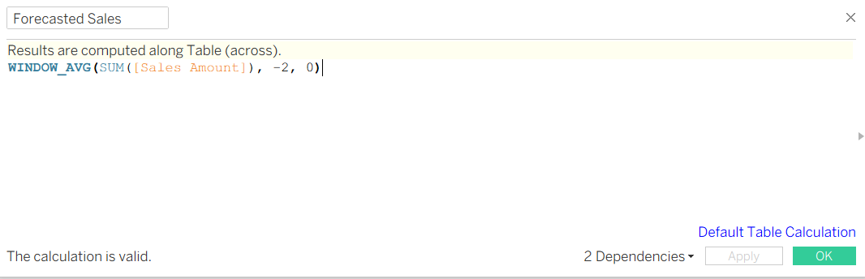

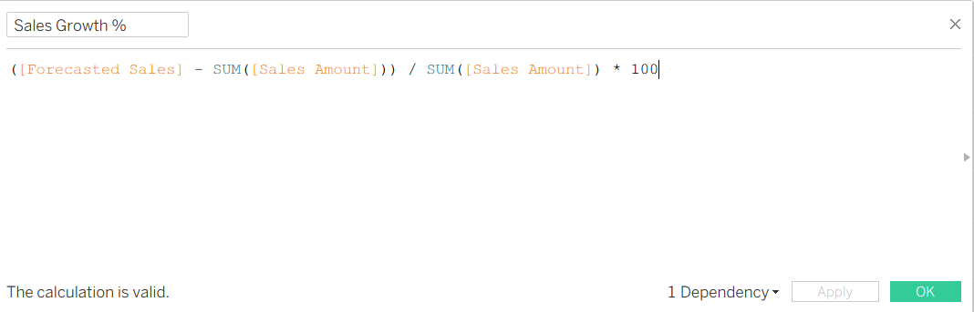

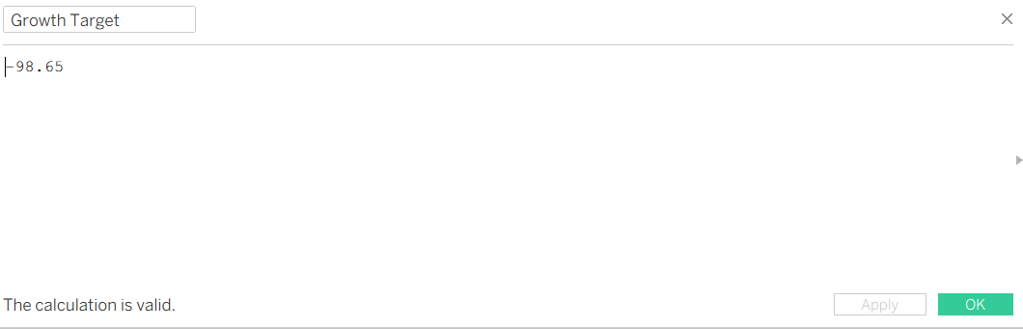

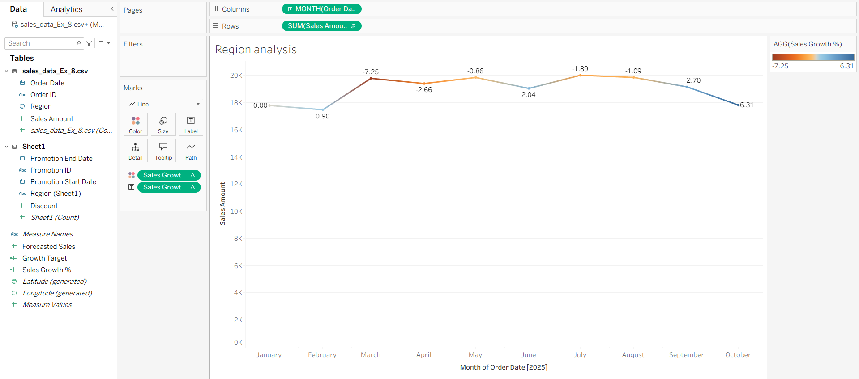

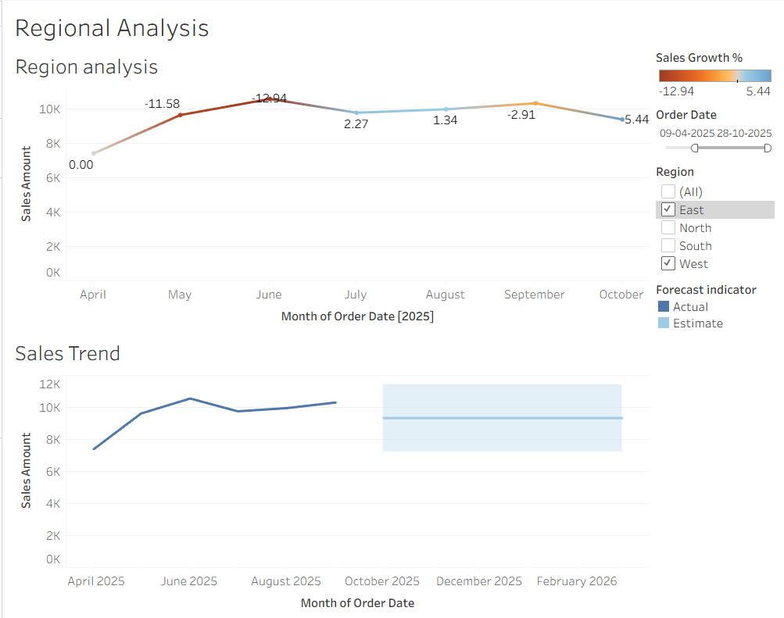

POST-LAB QUESTIONS (PROVIDE BRIEF ANSWERS TO THE FOLLOWING QUESTIONS)
1.How did forecasting help in predicting future sales trends for business planning?

Forecasting helped predict future sales by analyzing historical sales patterns and estimating expected sales for upcoming periods. The forecast provided an understanding of whether sales were likely to increase or decrease, which can help the business plan inventory, staffing, promotions, and budgets more effectively.

2. What forecasting method did you use, and why was it suitable for the dataset?

I used time-series forecasting with exponential smoothing in Tableau and also used a moving-average calculation for Forecasted Sales. This was suitable because the dataset contained historical sales organized by date, allowing Tableau to identify trends and patterns over time. Exponential smoothing is useful for sales data because it gives more importance to recent observations when predicting future values.

3. What challenges, if any, did you face regarding missing data or irregular time intervals?

The main challenges were ensuring that the date fields were in the correct format and that the sales data had consistent time intervals. Missing sales values or irregular dates could affect the accuracy of the forecast. Therefore, the data was cleaned, duplicates were removed, missing values were checked, and sales were aggregated consistently by month before forecasting.

4. How can predictive analytics influence decision-making in a retail environment?

Predictive analytics can help retailers make better decisions by estimating future demand and identifying expected sales trends. It can support inventory planning, pricing decisions, promotional strategies, staffing, and budgeting. For example, if the forecast indicates higher sales in a particular period or region, the retailer can increase inventory and prepare suitable promotions in advance.

5. What additional data could be integrated to improve forecast accuracy?

Additional factors that could improve forecast accuracy include:
- Competitor pricing and promotions
- Customer purchase history
- Discount and promotion effectiveness
- Seasonal and holiday information
- Economic indicators such as inflation and interest rates
- Weather conditions
- Store location and regional demand
- Online and offline sales data
- Product category and inventory levels
Integrating these variables with historical sales data could help explain changes in sales more accurately and produce better predictions.

RESULT:
The historical sales and promotions datasets were successfully cleaned, integrated, and modeled in Tableau and Power BI. Forecasting techniques provided predicted sales trends, growth percentages, and region-wise performance expectations. The resulting dashboards allowed managers to visualize actual vs. forecasted sales, enabling better planning and datadriven decision-making.

ASSESSMENT

Description |  | Max Marks | Marks Awarded
Pre Lab Exercise |  | 5
In Lab Exercise |  | 10
Post Lab Exercise |  | 5
Viva |  | 10
 | Total | 30
 | Faculty Signature

